Cab Technology Integration Lab (CTIL) Clean-Ops Plan

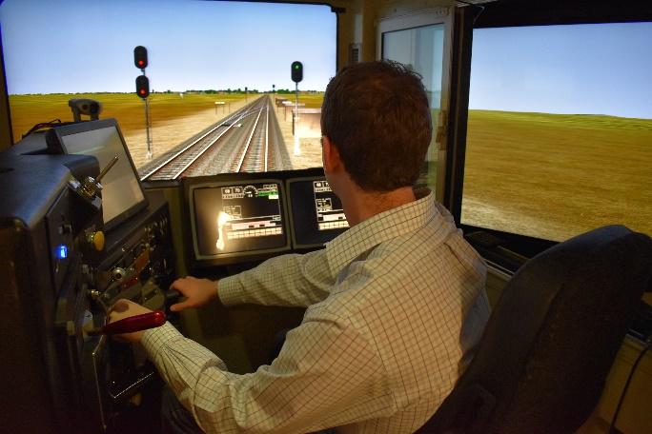

**Gina Melnik and Matthew Isaacs**

**Volpe National Transportation Systems Center**

**Version 1.1**

**Last updated January 2021**

# Document Change History

| **Document Version Number** | **Date** | **Description of Change** | **Page(s) Affected** | **Author Initials** |
| --- | --- | --- | --- | --- |
| 1.1 | 1/20/21 | Updated General Criteria bullet (wording and footnote link) to align with updated Massachusetts state information related to color-coding COVID-19 risk for each town. | 3 | GM |
| 1.1 | 1/20/21 | Added missing footnote regarding source of Appendix A. | 4 | GM |
| 1.1 | 1/20/21 | Added additional bullet under Safety Measures regarding providing a safe, secluded area for eating during multi-hour experiments that offer a lunch break. | 6 | GM |

# Background

This document outlines health and safety precautions related to COVID-19 that will be used when conducting human-subjects research in the Federal Railroad Administration’s (FRA’s) Cab Technology Integration Lab (CTIL) to protect the health and wellbeing of both experimenters and research participants. Because of the changing nature of the pandemic, this plan may undergo periodic updates to stay current with other guidance (e.g., Federal, state, or facility guidance) or to address any changes the lab deems needed to protect staff and research participants.

The CTIL is located at the U.S. Department of Transportation (DOT) Volpe National Transportation Systems Center (Volpe) in Cambridge, Massachusetts. The Volpe facility in which the simulation labs are housed, Building 6, is separate from the rest of the Volpe campus with limited staff access (enforced using keycard access) and very low occupancy. This supports our ability to keep the labs running in the time of COVID-19 with procedural modifications to support safety.

# Criteria for Human Subjects Research in CTIL

This plan is consistent with all general precautions for DOT labs prescribed by the document *Guidance for Resuming In-Person Human Subjects Data Collection in the Department of Transportation*[1] and complies with Volpe guidance related to COVID-19. Additional procedures specific to the CTIL and/or the Volpe lab space have been added to complete the current plan.

## General Criteria

Running subjects, also called participants, in the lab may occur under the following conditions:

* Massachusetts must be in Phase 3 of the reopening plan, which is the highest level of reopening prior to widespread treatment being available.
* The Volpe Center must be in at least Phase 2 of reopening (or a later phase).[2]
* The Volpe Center must be without a drop in phase occurring within the two weeks prior. (For example, if the Volpe Center drops from Phase 3 status to Phase 2 status, the lab would need to wait 2 weeks before continuing to run participants to determine that the rate of infection has stabilized.)
* Both Cambridge, Massachusetts and the town of the participant’s home must be coded green or better on the Mass.gov COVID-19 Weekly Public Health Report.[3]

# Participant Eligibility and Recruitment

* Persons at elevated risk for severe illness from COVID-19 [as defined by the Centers for Disease Control (CDC](https://www.cdc.gov/coronavirus/2019-ncov/need-extra-precautions/people-at-higher-risk.html)) at the time of the study (<https://www.cdc.gov/coronavirus/2019-ncov/need-extra-precautions/index.html>) will not be allowed to participate in research as participants nor experimenters.
* The latest information from the CDC about who is at risk will be shared with participants either through sharing the direct link to this information on the CDC website or through sharing a document that contains the latest CDC information. Participants will be asked to self-identify if they, or any member of their household, is at increased risk or otherwise uncomfortable participating. If the prospective participant answers “yes” then that individual will *not* be recruited for participation.
* During recruitment, the experimenter/recruiter must communicate to potential participants:
  + Information concerning potential risks of viral transmission and what precautions will be implemented to reduce risks thereof. (E.g., a document such as that in Appendix A may be used.[4],[5])
  + How participants will be screened for symptoms of COVID-19.
  + That failing screening will block participation until clear of infection per CDC guidance.[6]
  + That participants must agree to comply with Volpe and CTIL lab precautions in order to be permitted to participate in the study (screening, PPE, distancing, hand sanitation, etc.)
* Recruitment and participation of participants from outside the local community where the research is conducted (i.e., Suffolk county in Massachusetts) should be considered only when:
  + Necessary to represent the population who will benefit from research outcomes.
  + Risk levels of the research location and participant’s home communities are equivalent.[7]
  + Transmission risks of transportation do not exceed those in the research location and the participant’s home community.
* Procedures must be implemented to enable contact tracing.[8] Participants must be provided with a point of contact to give to a contact tracing authority if they exhibit symptoms within 14 days of participation. Experimenters must retain participant contact information to provide to a contact tracing authority if research personnel exhibit symptoms within 14 days of participation.

# Safety Measures

CTIL staff will implement the following safety measures to limit exposure to COVID-19. These measures include COVID-19 screener questions, individual safety, lab sanitization and materials safety.

* Lab visitors may only enter Building 6 when their presence is deemed essential for lab work to continue (i.e., when visitors are either research participants or someone with whom FRA-Volpe is partnering on a research effort and the visit is necessary for a project).
* All visitors must respond to a series of screening questions by email no sooner than 48 hours in advance of their planned visit to CTIL. (See Appendix B for screening questions and procedure.)
  + Participants who do not answer the screener questions will be denied entry.
  + Participants that answer “yes” to any of the screening questions will not be able to enter the Volpe facility and so will be instructed to stay home. (The participant must be symptom free for 14 days before being eligible to participate again.)
* Screening criteria signage will be posted at Volpe facility entrances and Volpe Security will instruct all individuals entering the facility to review posted signage regarding facility entry. Security will enforce the posted building restrictions against potential visitors who do not satisfy the building admittance criteria.
* Physical distancing (6 feet or more) from other individuals is mandatory. The laboratory is labeled with tape to mark this distance, as well as areas where participants may not enter. The experimenter will indicate to participants where to stand and sit so that distance can be maintained. When experimenters do not have to be in the same room as participants (as is typically the case), they can observe in the experimenter control room, which is entirely separate from the room that houses the locomotive cab.

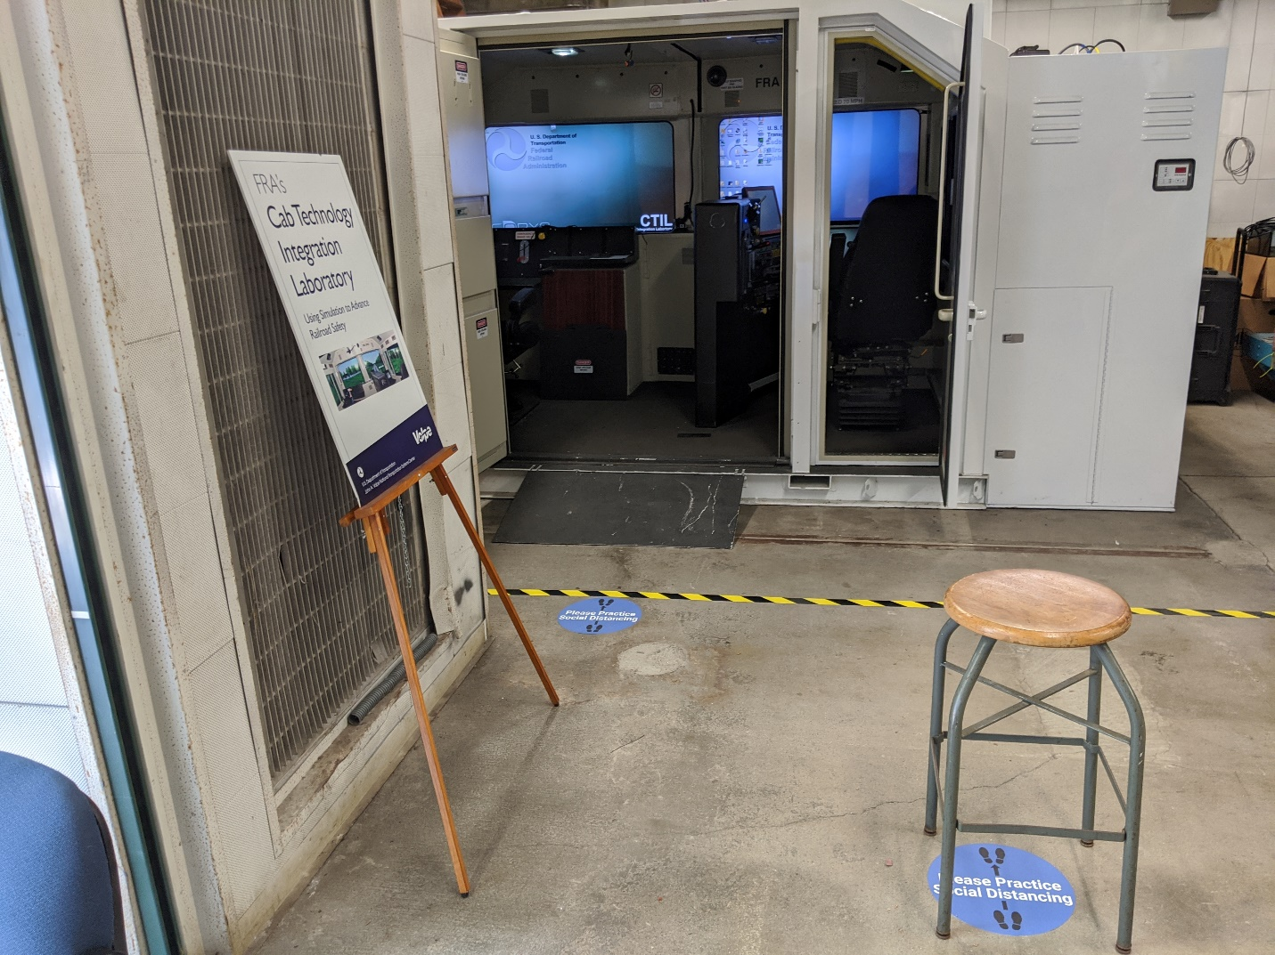

Figure 1: Observation area outside of CTIL cab. If experimenters are required to be in the same room as the participants during parts of data collection, they must remain behind the marked yellow line. Blue "please practice social distancing" stickers further demark six-foot distances between observers.

* Mask wearing is mandatory while on the Volpe premises for both Volpe staff and visitors. A mask is required at all times when indoors, as well as any time outdoors when a six-foot physical distance between people cannot be maintained. Experimenters will also wear face-shields.
* Visitors are expected to bring their own mask. Due to supply issues, Volpe cannot provide these. Visitors who arrive without a mask will not be granted access to the building.
* Participants and experimenters must clean hands upon both entering and exiting the building. This may be done by handwashing or by use of hand sanitizer. Furthermore, participants and CTIL staff are encouraged to use hand sanitizer at any time they wish while in the lab.
* In addition to daily facility cleaning provided by Volpe, CTIL staff will clean all laboratory equipment and touchpoints, before and after the lab is used, using 99% isopropyl alcohol[9] while wearing nitrile gloves.
* Laboratory staff will follow a checklist for sanitizing the lab to increase thoroughness. (See Appendix C.)
* When physical materials must be used (e.g., hard copy documents, pens), experimenters will follow the below procedures:[10]
  + Experimenters will provide unique copies of all shared materials for each participant. There will be no-reusing of physical materials.
  + At least two days prior to subject arrival, experimenters will assemble individual bags of participant materials (e.g., Informed Consent form) and experimenter materials (e.g., cleaning checklist) and write the date each bag was assembled with marker on its exterior. These bags will be separated and kept in a file drawer marked “unused forms.”
  + On experiment day, the experimenter and participant will each take one bag out of the file drawer, and use its contents for the experiment.
  + At the end of the experiment day, both experimenter and participant will return their completed forms to their own bags, write the current date on its exterior and drop them in a different drawer marked “completed forms.”
  + Two days after experiment day, laboratory staff will retrieve and scan all of the forms for that past experiment day, and dispose of the physical copies. Used pens in the bags will be thrown away.
* In lieu of using physical materials (e.g. hard copy documents, pens), experimenters may elect to use a tablet instead, provided that the tablet is cleaned in accordance with the instructions outlined in this document.
* Lab staff have set up a meeting table adjacent to a large bay door that can be opened to improve air exchange, weather permitting. Groups of 2-4 who are meeting (e.g., for experiment planning) are encouraged to use this space whenever possible.
* In the event that the participant is offered lunch as part of a multi-hour experiment, and they choose to accept that offer, a clean and secluded area will be provided for eating. This location will be sterilized both before and after the participant eats.
* CTIL-owned eye-tracking equipment will not be used at this time. Research partners may bring in their own eye-tracking equipment provided that the equipment does not require up-close contact with participants to set up and it is easily sanitized.

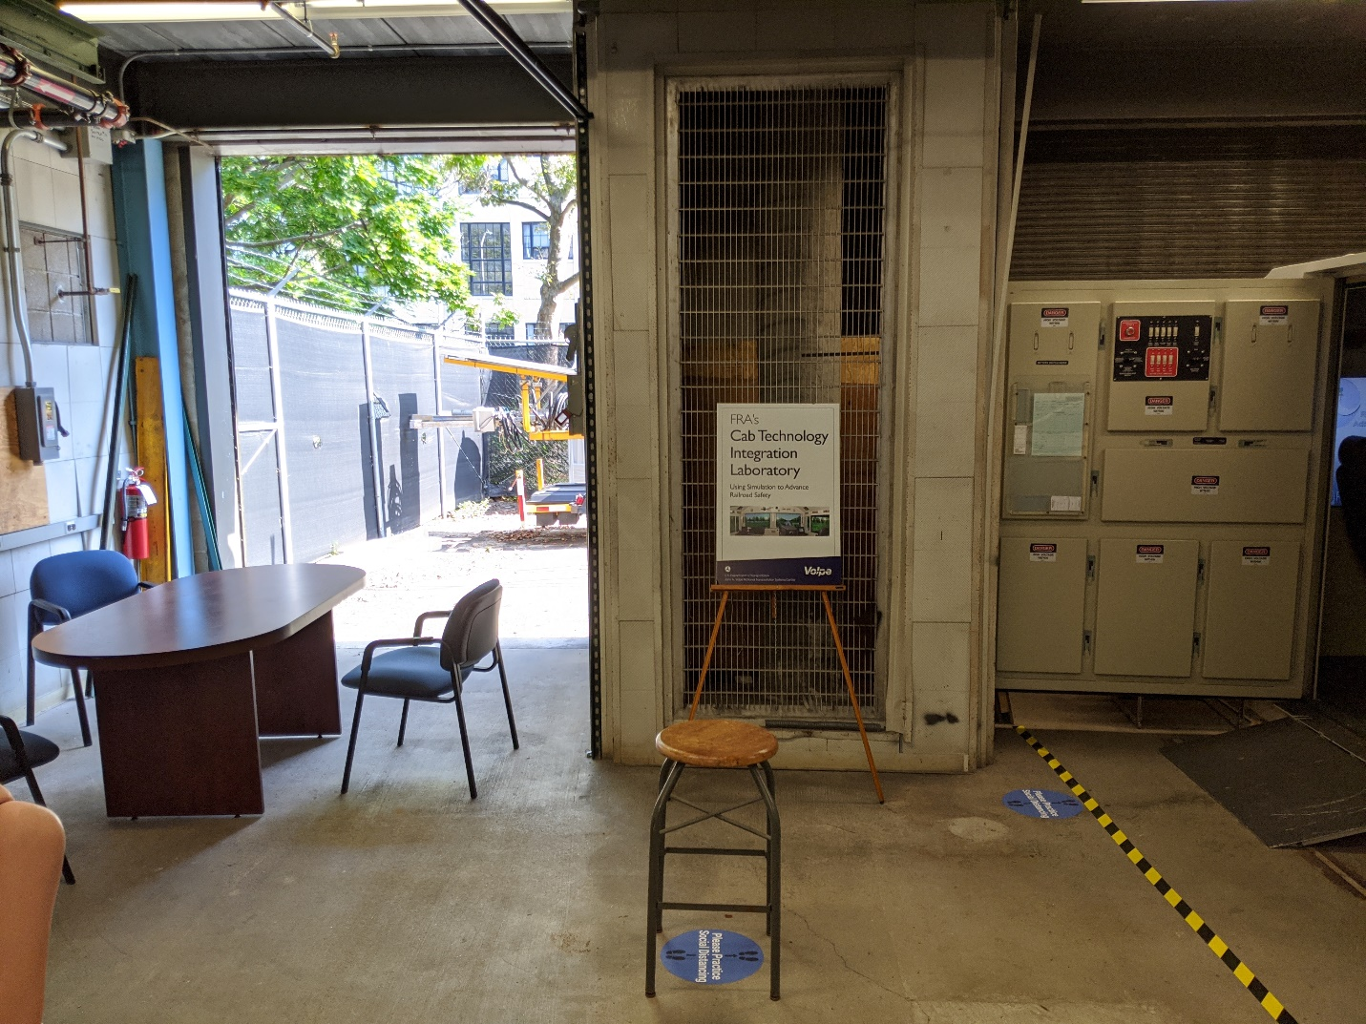

Figure 2: Meeting table located near CTIL rail cab. Groups of 2-4 meeting in the lab are encouraged to use this space to meet with the bay door open, weather permitting.

# Participant Timeline

Limiting the spread of COVID-19 requires that CTIL staff and participants follow the safety and security standards mandated by the state of Massachusetts, the Federal Government, the DOT, and Volpe.

The requirements that satisfy all of these groups are organized below into a three-part timeline of pre-arrival, day of visit, and post-visit steps.

## Pre-Arrival

In the days prior to a participant’s arrival at Volpe, **experimenters** will follow the below steps to facilitate access and limit exposure to COVID-19.

* **5 business days prior:** Experimenter will email the participant with:
  + An event reminder including the date and time of visit
  + A list of participant requirements from all three phases of this Participant Timeline
  + A request for vehicle information to obtain parking (if required)
  + A copy of the COVID-19 Screener Questions See questions in Appendix B.)
* **At least 2 business days prior:** Experimenter will notify Volpe security of an incoming participant and request parking.
* **2 business days prior:** 
  + Experimenter will screen themselves
  + Experimenter will email the participant with a reminder to return the screener questions before visiting Volpe.
* **1-2 business days prior:** If the participant answers “no” to all screener questions, the experimenter will provide final confirmation of the visit, including parking details. If the screener questions have not been received, the experimenter will call the participant to obtain the information. The experimenter will direct the participant to walk directly to the lab building, Building 6, after parking instead of going to the Volpe main entrance. (Security screening will be conducted outside the lab building.)

During this time, **participants** must follow the below steps before arriving at Volpe to ensure admittance:

* **At least 3 business days prior:** Participants requiring parking must provide vehicle information (make/model/year/plate number) to experimenter to ensure access.
* **Within 48 hours of arrival:** Participants must respond to the screening questions (Appendix B) by email, and notify Volpe if any of their answers are “yes” before their arrival.

## Day of Visit

On the day of the visit, **experimenters** will:

* Follow the procedures outlined in this plan (such as those involving PPE and distancing, lab sanitation, and materials safety), and direct participants to follow any procedures that apply to them.
* Turn away any participant that did not pass the screener questions, but arrived anyway.
* Turn away any participant that did not respond to the screener questions.
* Turn away any participant that arrives without a mask.

Volpe Security will screen participants outside of the building where CTIL is housed (Building 6), rather than inside of Building 1. At this time, security will also collect participants’ contact information for notification in the event of an outbreak.

On the day of the visit, **participants** must**:**

* Bring and wear a face covering while in the building and when unable to maintain a distance of at least 6 feet when interacting with any personnel on the grounds.
* Follow all posted signage regarding Volpe onsite safety requirements.
* Notify experimenters if any of their answers to screener questions have changed from “no” to “yes.”
* Notify experimenters if they begin to feel ill at any time during their visit, at which time the visit will be terminated.

## Post-Visit

After the visit, experimenters will repeat the lab sanitization procedures outlined in this document.

Any visitor who experiences symptoms or tests positive for COVID-19 within 14 days following their visit must notify their host. The host must then notify their supervisor and the Volpe’s Director of Office of Facilities Management, and provide information on who the individual may have come in contact with and where they were in the facility.

Any experimenter who experiences symptoms will notify anyone that has participated in a study over the prior 14 days, all other experimenters and CTIL team members, their supervisor, Volpe’s Director of the Office of Facilities Management, and FRA.

# Information for Institutional Review Boards (IRBs)

CTIL projects may be approved through a variety of IRBs and these projects would need to satisfy whatever requirements or conditions the IRB deems necessary to protect research participants. *As part of* that process (not in lieu of), the CTIL team expects **principal investigators (PIs)**[11] to adhere to the following actions with regard to the IRB they use to review the research.

* Submit a protocol, or an amendment to an existing protocol, describing how precautions will be taken to minimize risk of viral transmission to a level equivalent or below those of daily life in the community in which research will be accomplished. (PIs may elect to simply share the current document with their IRBs to meet this criteria.)
  + A copy of this, or a similar document summarizing this information, must be available in the lab at all times for experimenter reference.
  + The protocol or amendment must address all of the General Precautions described in the document *Guidance for Resuming In-Person Human Subjects Data Collection in the Department of Transportation*. (Already covered for those submitting the current document.)
* Articulate the safety benefit that justifies accepting minimal risk of viral transmission.
* Submit a consent form or addendum for participants communicating potential risks of viral transmission and what will be implemented or required to reduce risk of viral transmission to a level equivalent or below daily life in the community in which research will be conducted. (The PI may use the document provided in Appendix A to meet this criteria. If the PI prefers to develop their own document for this purpose, the CTIL team must approve the document as a comparable substitute.)
* Define how cleaning will be accomplished routinely and in the event of a COVID-19 case. (The PI may either pull information from the current document or submit the current document to their IRB.)
* Define how contact tracing will be *enabled* following a presumed/probable/confirmed case among participants or researchers. (The PI may either pull information from the current document or submit the current document to their IRB.)

# Communications and Staff Training

* Prior to being permitted to run participants in the CTIL, experimenters must be familiar with:
  + CDC information on preventing sickness https://www.cdc.gov/coronavirus/2019-ncov/prevent-getting-sick/index.html
  + CDC video on proper handwashing <https://youtu.be/d914EnpU4Fo>
* At all times, the experimenter workstation must have available for reference a copy of:
  + The current document
  + IRB-approved experiment protocol, including any precautions taken to minimize risk of viral transmissions
* While participants are being run, lab staff will meet weekly or biweekly (as needed) to discuss lab operations, any issues or updates to procedures needed, etc.

# Response Planning

## What if the prospective participant screens positively for risk factors of COVID-19?

* If the positive screen happens before the participant comes to Volpe, they will be asked to stay home. If the positive screen happens after the participant comes to the center, Volpe will deny entry. Volpe staff will recommend that the individual self-quarantine and notify their doctor. The participant can visit Volpe once they are able to answer ‘no’ to all screening questions *as well as* either having a negative test result or being symptom-free for 14 days.

## What if one of the lab staff screens positively for risk factors of COVID-19?

* If the lab staff member has been in the office within the last two weeks, Volpe staff will notify their supervisor and the director of Volpe Facilities Management who will:
  + Notify those in recent contact with the individual and recommend they self-quarantine until obtaining a negative test result or until they have had no symptoms for two weeks.
  + Clean and sanitize the lab according to CDC cleaning protocols.
* If the staff member screening positively has not been in the office during the last two weeks, another experimenter may run the experiment.

## What if a visitor feels ill while at Volpe?

* Visitors who begin to feel ill while at in the facility should notify the experimenter and immediately leave the facility. If emergency medical assistance is required, the experimenter will contact Security (to help get assistance) or Volpe’s on-site nurse by calling 617-494-2610 or x2610 from Volpe phone.
* Volpe staff will notify their supervisor and the director of Volpe Facilities who will:
  + Notify those in recent contact with the individual and recommend they self-quarantine until obtaining a negative test result or until they have had no symptoms for two weeks.
  + Clean and sanitize the lab according to CDC cleaning protocols.
  + Notify lab staff when it is okay to use the lab again. The lab will not be used until that time.

## What if the participant or experimenter feel symptoms in the days after the experiment?

* Any visitor who experiences symptoms or tests positive for COVID-19 within 14 days after having been in the facility must notify their Volpe host, i.e., the experimenter. (The visitor may also notify the Volpe Center if they cannot find experimenter contact information.) Staff will notify their supervisor and the director of Volpe Facilities, who will:
  + Notify those in recent contact with the individual and recommend they self-quarantine until obtaining a negative test result or until they have had no symptoms for two weeks.
  + Clean and sanitize the lab according to CDC cleaning protocols.
  + Notify lab staff when it is okay to use the lab again. The lab will not be used until that time.

# Appendix A. COVID-19 Briefing sheet

**Important Information about COVID-19 and Research Participation**

The Volpe Center and our research partners believe our primary responsibility related to research is to protect the safety of our research participants.

COVID-19 refers to the Coronavirus that is being spread across people in our communities. We need to provide you with important information about COVID-19, and to tell you about ways your study participation might change because of COVID-19 related risk.

If you are considering joining a study, it is important that you consider the following information to determine if study participation is right for you at this time.

**How is COVID-19 spread?** COVID-19 is a respiratory virus spread by respiratory droplets, mainly from person-to-person. This can happen between people who are in close contact with one another (less than 6 feet). It is also possible that a person can get COVID-19 by touching a surface or object (such as a doorknob or counter surface) that has the virus on it, then touching their mouth, nose or eyes.

**Can COVID-19 be prevented?** Current ways to minimize the risk of exposure to COVID-19 include “social distancing” which is a practice to decrease the potential for direct exposure to others who may have been exposed to COVID-19, for example by avoiding large gatherings or refraining from shaking hands with others. It is important to understand that since study participation may include increased travel outside of your home and increased exposure to others within a research site it may increase your exposure to COVID-19. At this time there is no vaccination to prevent COVID-19 infection.

**What are the risks of COVID-19?** For most people, the new coronavirus causes only mild or moderate symptoms, such as fever and cough. For some, especially older adults and people with existing health problems, it can cause more severe illness, including pneumonia. While we are still learning about this virus, the information we have right now suggests that about 3 of 100 people who are infected might die from the virus.

**Who is most at risk?** Individuals over 60 and with chronic conditions such as cancer, diabetes and lung disease have the highest rates of severe disease from the infection.

**How could your participation in this research change as a result of COVID-19?** There are several ways we try to minimize your risk. These include the following:

* Those that self-identify as high-risk or have high-risk members in their household are not eligible to participate.
* We screen every participant for symptoms or possible exposure to those with COVID-19 and only those that pass screening will be eligible to participate.
* The number of people in the lab at a given time will be kept to a bare minimum and strict adherence to social distancing will be expected throughout your time at Volpe.
* Experimenters and participants are expected to use PPE (to include masks) at all times indoors as well as maintain good hand hygiene.
* Experimenters will disinfect the lab space both before and after each participant visits using disinfectant that meets CDC and EPA criteria for use against COVID-19.

A more detailed description of all our safety precautions is provided in the CTIL Clean-Ops Plan document. If you would like a copy of this document, your contact(s) for this study (experimenter and/or participant recruiter) can provide you with a digital copy.

If you have questions about COVID-19 and your participation in research, please talk to your contact for this study.

# Appendix B. Screening Questions and procedure

Volpe procedures require that anyone hosting a visitor must screen approved visitors in advance of the visitor arriving to the building. However, this screening should take place no sooner than 48 hours prior to the planned visit. A CTIL team member will email the visitor the screening questions, which are currently as follows[12]:

* Is your temperature at or more than 100.4 degrees F (38.0 degrees C)?
* Do you feel unwell or have any of the following symptoms: Fever or chills, Cough or shortness of breath, Muscle pain, Headache, Sore throat, and/or New loss of taste or smell?
* Within the last 14 days, have you been in close contact (within 6 feet) with someone who has an active case of laboratory-confirmed COVID-19?
* Within the last 14 days, have you been in close contact (within 6 feet) with someone who is ill, or demonstrates any of the above symptoms?
* In the last 14 days, have you received instructions from a public health authority to self-observe, self-isolate, or self-quarantine?
* Have you traveled outside of the US within the past 2 weeks?

If a visitor answers “yes” to any of the screening questions, Volpe will:

* *Not* admit the visitor to the building and the individual will be instructed to stay home.
* Notify the participant that they can visit Volpe once they are able to answer ‘no’ to all screening questions *and* they have had no symptoms for 14 days.
* Recommend that the individual self-quarantine until they can get further guidance from their doctor.

Volpe lab staff will also screen themselves according to the same protocol.

# Appendix C. Checklist for lab cleaning

The following checklist will be used by experimenters for lab cleaning prior to and following each experimental session.

**In researcher control room:**

__ Workstation desk

__ Workstation chair

__ Keyboards

__ Mice

__ Microphone

__ Remote controls

__ Any other chairs used

__ Writing utensils

__ Phone

__ Door handle (both sides)

__ Table top behind desk (if used)

__ Light switch

**Tower spaces (if touched)**

__ Buttons on all 4 tower computers

__ Button on small tower monitor

__ Video mixer surface

__ Handle for tower

__ Outside of tower cage (high-touch areas)

**Short Tower spaces (if touched)**

__ Video Recorder

__ Picture-in-picture modules

__ Sound mixer

**In locomotive cab:**

__ Power switch and UPS

__ Handles on power switch door

__ Engineer screens

__ Engineer Desktop

__ Engineer control stand, including

__ All knobs and levers

__ Top of control stand console

__ Engineer windowsill (commonly used as an armrest)

__ Engineer chair

__ Conductor desktop

__ Conductor horn and brake

__ Conductor windowsill (commonly used as an armrest)

*__* Conductor chair

__ TV Remotes

__ Overhead cab light switches

__ Air conditioning controls on the outside of cab

**Bay-area meeting space:**

__ Meeting table (if used)

__ Chairs (if used)

__ Light switches

**Other:**

___Water fountain button and handle (if use becomes permitted; currently use is disallowed by Volpe)

1. Applicable criteria from that document have been incorporated into the current document.
2. Phase 2 is considered acceptable given that CTIL research is conducted in building 6, which is a low-occupancy laboratory building separate from the other buildings on the Volpe campus.
3. <https://www.mass.gov/info-details/covid-19-response-reporting#covid-19-weekly-public-health-report->
4. Appendix A provides the CTIL standard document for communicating this information. However, CTIL works with a variety of Institutional Review Boards and so will accept alternative, comparable means of informing subjects as long as it is approved by the IRB approving that project.)
5. Appendix A has been adapted, with permission, from the original version developed by Johns Hopkins, <https://www.hopkinsmedicine.org/institutional_review_board/news/covid19_information/COVID19RiskInformationSheetForParticipants.docx>.
6. <https://www.cdc.gov/coronavirus/2019-ncov/hcp/return-to-work.html>
7. Judged by comparing county information using references such as <https://covid19-betadashboard.eon.faa.gov/> and <https://covidusa.net> and local county health department).
8. Volpe staff are not trained in contact tracing, but it is our goal to be able to enable any professional contract tracers working to protect public safety by maintaining a record of basic information such as the date the participant was here, who the experimenter(s) was that day, and who else was in the lab building.
9. Isopropyl alcohol above 70% is [recommended for disinfection by CDC](https://www.cdc.gov/coronavirus/2019-ncov/community/disinfecting-building-facility-H.pdf), while products with minimal water carry the least risk to computer and electrical equipment.
10. This only applies in the event that there are paper materials to be distributed. Some of our research partners may develop alternative protocols that do not require paper materials to be distributed.
11. For projects led by one of our research partners, this would be the individual leading the project at the partnering organization.
12. Screening questions may be updated, if Volpe facilities determines this is needed.